## **Lab 22: Android Bluetooth**

# **Introduction**

All Bluetooth-related tasks are carried out via the Android BluetoothAdapter class. A Bluetooth device is by default in an undiscoverable mode. This means that only people who have already associated with a device will see it if we turn on the Bluetooth. Other than the associated devices, this gadget cannot be seen. We enable the Discoverable option, which makes the gadget global to its neighborhood, to make it apparent. Any list that includes new or previously paired devices now includes this device. Applications utilising Bluetooth transfers that pair music players or smart watches with other devices are quite straightforward.

**Let’s get Started:**

In this exercise, we will learn how to enable and disable Bluetooth in our Android application using Kotlin as our programming language.

**Step 1:** open **activity_main.xml** file from **\res\layout** folder path and write the code like as shown below.

**activity_main.xml**

*<?*xml version="1.0" encoding="utf-8"*?>*<LinearLayout  
 xmlns:android="http://schemas.android.com/apk/res/android"  
 android:layout_width="match_parent"  
 android:layout_height="match_parent"  
 android:paddingLeft="10dp"  
 android:paddingRight="10dp"  
 android:background="#C2185B">  
  
 *<!--Turn ON Button-->* <Button  
 android:id="@+id/btnOn"  
 android:layout_width="wrap_content"  
 android:layout_height="wrap_content"  
 android:layout_toLeftOf="@id/btnDiscoverable"  
 android:text="Blutooth ON" />  
  
 *<!--Discoverable Button-->* <Button  
 android:id="@+id/btnDiscoverable"  
 android:layout_width="wrap_content"  
 android:layout_height="wrap_content"  
 android:layout_centerHorizontal="true"  
 android:text="Search" />  
  
 *<!--Turn OFF Button-->* <Button  
 android:id="@+id/btnOFF"  
 android:layout_width="wrap_content"  
 android:layout_height="wrap_content"  
 android:layout_toRightOf="@+id/btnDiscoverable"  
 android:text="Bluetooth OFF" />  
  
 </LinearLayout>

**Step 2:** Open main [activity](https://www.tutlane.com/tutorial/android/android-activity-lifecycle) file **MainActivity.kt** and write the code like as shown below.

**MainActivity.kt**

**package** com.example.demopluralsightbluetooth  
  
**import** android.Manifest  
**import** android.bluetooth.BluetoothAdapter  
**import** android.content.Intent  
**import** android.content.pm.PackageManager  
**import** android.os.Bundle  
**import** android.support.v4.app.ActivityCompat  
**import** android.support.v7.app.AppCompatActivity  
**import** android.widget.Button  
**import** android.widget.Toast  
  
**class** MainActivity : AppCompatActivity() {  
 **override fun** onCreate(savedInstanceState: Bundle?) {  
 **super**.onCreate(savedInstanceState)  
 setContentView(R.layout.*activity_main*)  
  
 **val** btnOn = findViewById<Button>(R.id.*btnOn*)  
 **val** btnOff = findViewById<Button>(R.id.*btnOFF*)  
 **val** btnDisc = findViewById<Button>(R.id.*btnDiscoverable*)  
  
 **val** bAdapter = BluetoothAdapter.getDefaultAdapter()  
  
 btnOn.setOnClickListener **{  
  
 if** (bAdapter == **null**) {  
 Toast.makeText(*applicationContext*, **"Bluetooth Not Supported"**, Toast.*LENGTH_SHORT*).show()  
 } **else** {  
  
 **if** (!bAdapter.*isEnabled*) {  
 **if** (ActivityCompat.checkSelfPermission(  
 **this**,  
 Manifest.permission.*BLUETOOTH_CONNECT* ) != PackageManager.*PERMISSION_GRANTED* ) {  
 }  
 startActivityForResult(Intent(BluetoothAdapter.*ACTION_REQUEST_ENABLE*), 1)  
 Toast.makeText(*applicationContext*, **"Bluetooth Turned ON"**, Toast.*LENGTH_SHORT*).show()  
 }  
 }  
 **}** btnOff.setOnClickListener **{** bAdapter!!.disable()  
 Toast.makeText(*applicationContext*, **"Bluetooth Turned OFF"**, Toast.*LENGTH_SHORT*).show()  
 **}** btnDisc.setOnClickListener **{  
 if** (!bAdapter!!.*isDiscovering*) {  
 startActivityForResult(Intent(BluetoothAdapter.*ACTION_REQUEST_DISCOVERABLE*), 1)  
 Toast.makeText(*applicationContext*, **"Making Device Discoverable"**, Toast.*LENGTH_SHORT*).show()  
 }  
 **}** }  
}

**Step 3:** Open main [activity](https://www.tutlane.com/tutorial/android/android-activity-lifecycle) file **AndroidManifest.xml** and write the code like as shown below.

*<?*xml version="1.0" encoding="utf-8"*?>*<manifest xmlns:android="http://schemas.android.com/apk/res/android"  
 xmlns:tools="http://schemas.android.com/tools">  
 <uses-permission android:name="android.permission.BLUETOOTH"/>  
 <uses-permission android:name="android.permission.BLUETOOTH_ADMIN"/>  
 <uses-permission android:name="android.permission.ACCESS_COARSE_LOCATION"/>  
 <uses-permission android:name="android.permission.BLUETOOTH_ADVERTISE" />  
 <uses-permission android:name="android.permission.BLUETOOTH_CONNECT" />  
  
 <uses-permission android:name="android.permission.BLUETOOTH_SCAN" />  
  
 <application  
 android:allowBackup="true"  
 android:dataExtractionRules="@xml/data_extraction_rules"  
 android:fullBackupContent="@xml/backup_rules"  
 android:icon="@mipmap/ic_launcher"  
 android:label="@string/app_name"  
 android:roundIcon="@mipmap/ic_launcher_round"  
 android:supportsRtl="true"  
 android:theme="@style/Theme.DemoPluralSightBluetooth"  
 tools:targetApi="31">  
 <activity  
 android:name=".MainActivity"  
 android:exported="true">  
 <intent-filter>  
 <action android:name="android.intent.action.MAIN" />  
  
 <category android:name="android.intent.category.LAUNCHER" />  
 </intent-filter>  
  
 <meta-data  
 android:name="android.app.lib_name"  
 android:value="" />  
 </activity>  
 </application>  
  
</manifest>

**Step 4: Check Output on Android Emulator and it should look like as given below.**

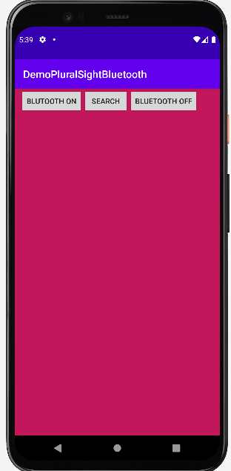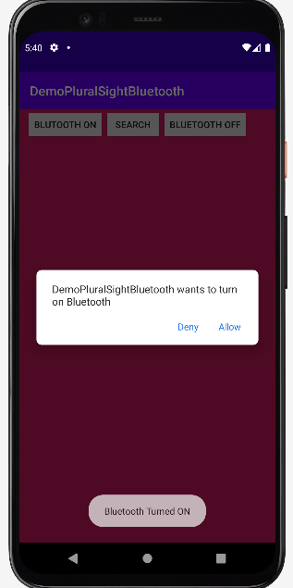

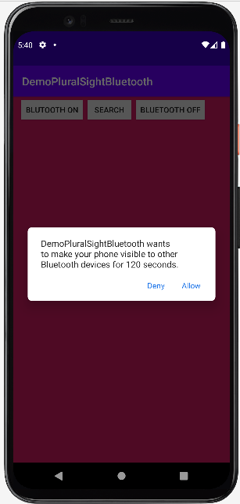 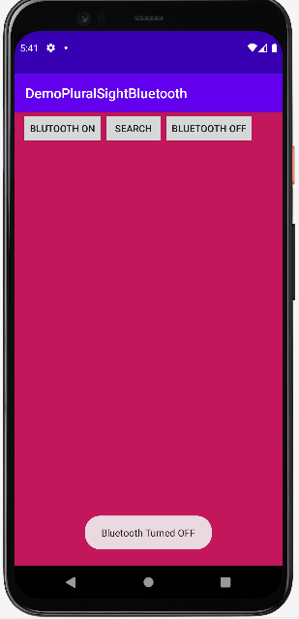

**Voila!!** We have successfully completed this lab.